**WEEK-5**

Creating Microservices for account and loan

Account Microservice

**AccountApplication.java**

package com.cognizant.account;

import org.springframework.boot.SpringApplication;

import org.springframework.boot.autoconfigure.SpringBootApplication;

import org.springframework.context.annotation.ComponentScan;

*@SpringBootApplication*

*@ComponentScan*(basePackages = "com.cognizant")

public class AccountApplication {

public static void main(String[] args) {

SpringApplication.*run*(AccountApplication.class, args);

}

}

**AccountController.java**

package com.cognizant.controller;

import org.springframework.web.bind.annotation.GetMapping;

import org.springframework.web.bind.annotation.PathVariable;

import org.springframework.web.bind.annotation.RestController;

import java.util.HashMap;

import java.util.Map;

@RestController

public class AccountController {

@GetMapping("/accounts/{number}")

public Map<String, Object> getAccountDetails(@PathVariable String number) {

Map<String, Object> response = new HashMap<>();

response.put("number", number);

response.put("type", "savings");

response.put("balance", 234343);

return response;

}

}

OUTPUT

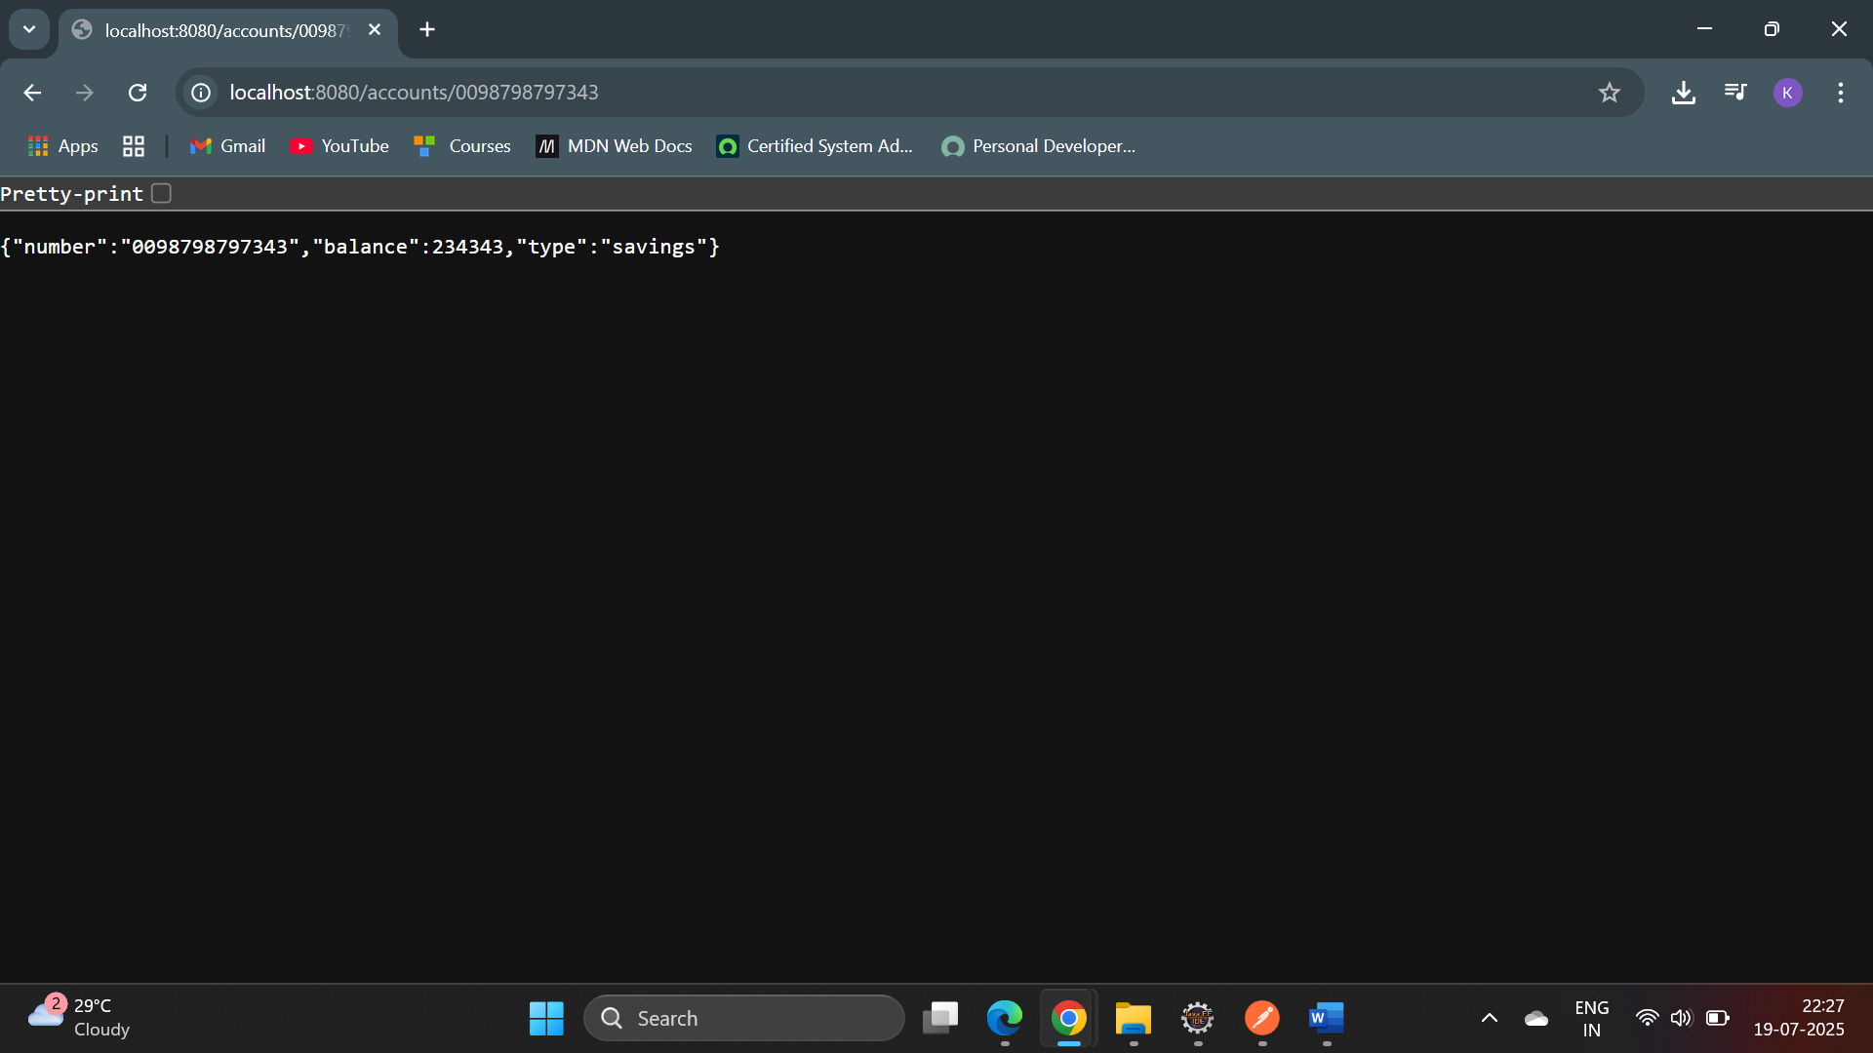

**Loan Microservice**

**LoanApplication.java**

package com.cognizant.loan;

import org.springframework.boot.SpringApplication;

import org.springframework.boot.autoconfigure.SpringBootApplication;

@SpringBootApplication

public class LoanApplication {

public static void main(String[] args) {

SpringApplication.run(LoanApplication.class, args);

}

}

**LoanController.java**

package com.cognizant.loan.controller;

import org.springframework.web.bind.annotation.GetMapping;

import org.springframework.web.bind.annotation.PathVariable;

import org.springframework.web.bind.annotation.RestController;

import java.util.Map;

*@RestController*

public class LoanController {

*@GetMapping*("/loans/{number}")

public Map<String, Object> getLoanDetails(*@PathVariable* String number) {

return Map.*of*(

"number", number,

"type", "car",

"loan", 400000,

"emi", 3258,

"tenure", 18

);

}

}

application.properties

spring.application.name=loan

server.port=8081

OUTPUT

